**<MAKK>**

**<Banking and Money Transfer System>**

**Use Case Report**

**Revision History**

|  |  |  |  |  |
| --- | --- | --- | --- | --- |
| **Authors** | **Description of Change** | **Sections** | **Rev** | **Date** |
| Maxfield Wilhoite | Initial Use Case Report | All | 0 | 2/13/2018 |
| Alexander Truong | Added additional fields or detailed descriptions regarding account creation, transferring, withdrawing, confirmations, account alerting, bill paying, and card information | 2.2.1, 2.2.5, 2.2.6, 2.2.8, 2.2.9, 2.2.10,  2.2.11, 2.2.12 | 1 | 2/25/2018 |
| Maxfield Wilhoite | Changed use case 2.2.6 to reflect feedback | 2.2.6 | 2 | 2/28/2018 |

**Table of Contents**

1 Team Description 4

2 Project Description 4

2.1 Use Case Diagram 5

2.2 Use Case List 6

2.2.1 <Create Account> 6

2.2.2 <User Login> 7

2.2.3 <User Log Out> 7

2.2.4 <Edit Account Settings> 8

2.2.5 <Transfer Funds> 8

2.2.6 <Set Minimum Balance> 9

2.2.7 <Deposit Funds> 10

2.2.8 <Receive Confirmations> 10

2.2.9 <Account Alerts> 11

2.2.10 <Pay Bills> 11

2.2.11 <Request Debit Card> 12

2.2.12 <Disable Debit Card> 12

2.2.13 <Enable Debit Card> 13

2.2.14 <Cancel Debit Card> 13

# Team Description

|  |  |
| --- | --- |
| **Team Member Name** | **Email Address** |
| Maxfield Wilhoite | maxw@csu.fullerton.edu |
| Kiren Syed | kirensyed@csu.fullerton.edu |
| Alexander Truong | Alexbt1992@csu.fullerton.edu |
| Kenny Chao | kchao@csu.fullerton.edu |
|  |  |
|  |  |

# Project Description

Statement of Purpose: Develop a secure and free banking program.

Detailed Description: Develop a banking system that allows users to deposit, withdraw, and transfer money with ease. Allow users to obtain debit cards and loans from their account. Our team will implement a user login system, that will allow them to access their bank account and be able to receive and transfer funds between other users.

## Use Case Diagram

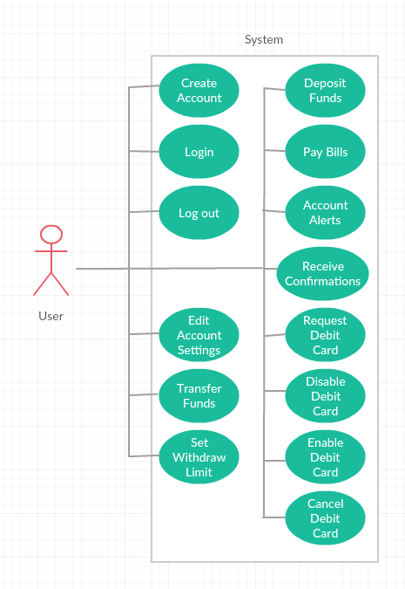

## Use Case List

|  |  |  |
| --- | --- | --- |
| **Use Case** | | |
| **Sequence Number** | **Actor** | **Goal** |
| 1 | User | Create Account |
| 2 | User | Account Login |
| 3 | User | Account Log Out |
| 4 | User | Edit Account Settings |
| 5 | User | Transfer Funds |
| 6 | User | Set Minimum Balance |
| 7 | User | Deposit Funds |
| 8 | User | Receive Confirmations |
| 9 | User | Account Alerts |
| 10 | User | Pay Bills |
| 11 | User | Request Debit Card |
| 12 | User | Disable Debit Card |
| 13 | User | Enable Debit Card |
| 14 | User | Cancel Debit Card |

### <Create Account>

Primary Actor: User

Secondary Actors(s): System

Goal in Context: User creates an account and associates or links a bank account with it.

Preconditions: User has the banking program downloaded.

Additional Description: This is the initial prerequisite that all users must do to use the program.

#### <Account Creation Success>

The user is successful in creating an account.

#### <Account Creation Failure >

The user fails to create an account and is prompted to edit the credentials they entered. This could occur if they entered a username that is already in use or they entered an invalid credential (i.e. invalid SSN)

### <User Login>

Primary Actor: User

Secondary Actors(s): System

Goal in Context: The user logs into their account using their login credentials.

Preconditions: The user has an account.

Additional Description: The user enters their username and password into the program, when prompted, allowing them access to their bank account.

#### <Login Success>

The user successfully logs in granting them access to their account.

#### <Login Failure >

The user fails to provide the correct user login information and is not given access to that account.

### <User Log Out>

Primary Actor: User

Secondary Actors(s): System

Goal in Context: The user logs out of their account.

Preconditions: The user is logged in

Additional Description: The user selects the option to log out of their account disconnecting usage of the account.

#### <Successful Log Out>

The user is successfully logged out of their account.

### <Edit Account Settings>

Primary Actor: User

Secondary Actors(s): System

Goal in Context: The user can edit their personal settings.

Preconditions: The user is logged into their account.

Additional Description: The user can change their linked email or password for their account.

#### <Account Settings Change Success>

The user is successful in editing their account settings.

#### <Account Settings Change Failure>

The user is unsuccessful in changing their account settings. This could occur from invalid credentials entered (entering an invalid email address)

### <Transfer Funds>

Primary Actor: User

Secondary Actors(s): System

Goal in Context: The user can transfer funds from their account to another user of the system.

Preconditions: The user is logged in and has enough money in their account to make the transfer.

Additional Description: The user enters the person who they want to transfer funds to, then selects how much they would like to transfer. The system then withdraws the money from their account and sends it to the entered person.

#### <Transfer Funds Successful>

The user successfully transfers funds from their account.

#### <Transfer Funds Failure – Funds>

The user is unable to transfer funds with the amount of funds they entered to transfer.

#### <Transfer Funds Failure – Recipient>

The user is unable to transfer funds to the person they entered to transfer funds to.

#### <Transfer Funds Failure – Minimum Balance>

The user is unable to transfer funds if the person attempts to transfer funds more than their minimum balance.

#### <Transfer Funds Failure – Limit>

The user is unable to transfer funds if the amount entered exceeds the transfer limit.

### <Set Minimum Balance>

Primary Actor: User

Secondary Actors(s): System

Goal in Context: The user can place a limit on the minimum balance of their account.

Preconditions: The user is logged in and has more money in their account than the limit amount.

Additional Description: The user enters the amount of money they wish to set as the minimum amount of money in their account.

#### <Set Minimum Balance Success>

The user successfully sets the minimum balance of their account.

#### <Set Minimum Balance Failure>

The user is unable to set the withdraw limit to the entered amount.

### <Deposit Funds>

Primary Actor: User

Secondary Actors(s): System

Goal in Context: The user deposits funds into their account.

Preconditions: The user is logged in.

Additional Description: The user deposits funds into their account with a debit or credit card.

#### <Deposit Funds Success>

The user successfully deposits funds into their account.

#### <Deposit Funds Failure>

The user unsuccessfully deposits funds into their account. This occurs with invalid information.

### <Receive Confirmations>

Primary Actor: User

Secondary Actors(s): System

Goal in Context: The user receives confirmations about their account status or balance.

Preconditions: The user has an account.

Additional Description: The user receives confirmations of successful deposits and transfers.

#### <Confirmations via Email>

The user receives confirmations about the success or failure of the actions of their account via their email they have registered.

### <Account Alerts>

Primary Actor: User

Secondary Actors(s): System

Goal in Context: The user receives alerts about their account.

Preconditions: The user has an account and an unsuccessful scenario has occurred.

Additional Description: The user receives alerts of unsuccessful or unauthorized logins, deposits, transfers, and account settings changes.

#### <Alerts via email>

The user receives alerts about their account via their email they have registered.

### <Pay Bills>

Primary Actor: User

Secondary Actors(s): System

Goal in Context: The user pays bills directly from their account.

Preconditions: The user is logged in and has enough funds in their account.

Additional Description: The user enters the information needed to pay a bill.

#### <Pay Bills Success>

The user successfully pays their bills.

#### <Pay Bills Failure>

The user unsuccessfully pays their bills. This occurs when incorrect information regarding invalid transfer recipients, insufficient funds, or incorrect payment information is entered.

### <Request Debit Card>

Primary Actor: User

Secondary Actors(s): System

Goal in Context: The user requests a debit card to be sent to them.

Preconditions: The user is logged in.

Additional Description: The user enters their mailing address and then receives a debit card in the mail.

#### <Request Debit Card Success>

The user requests a debit card and is sent one.

#### <Request Debit Card Failure>

The user is unable to request a debit card. They already have the allotted number of cards or their account information is incorrect.

### <Disable Debit Card>

Primary Actor: User

Secondary Actors(s): System

Goal in Context: The user temporarily disables the use of a debit card.

Preconditions: The user is logged in and has a debit card

Additional Description: The user selects to disable a debit card, making no purchases possible with that card.

#### <Disable Debit Card Success>

The user successfully disables their debit card.

#### <Disable Debit Card Failure>

The user does not have a debit card and thus can not disable it. The debit card is already disabled and cannot be disabled again.

### <Enable Debit Card>

Primary Actor: User

Secondary Actors(s): System

Goal in Context: The user enables their disabled debit card.

Preconditions: The user is logged in and has a debit card disabled.

Additional Description: The user selects the disabled card to enable allowing purchases to be made with that card.

#### <Enable Debit Card Success>

The user is successful in enabling their disabled debit card.

#### <Enable Debit Card Failure>

The user is unable to enable their debit card. This occurs when there is no disabled debit card.

### <Cancel Debit Card>

Primary Actor: User

Secondary Actors(s): System

Goal in Context: The user cancels the use of a debit card.

Preconditions: The user is logged in and has a debit card.

Additional Description: The user cancels the use of the debit card disabling the card permanently.

#### <Cancel Debit Card Success>

The user successfully cancels the debit card.